SPECIAL REPORT • THE COST OF A HOME

When money costs more,
homes move less
The mortgage-rate shock has frozen America’s housing market more effectively than it has deflated house prices. The Southwest is feeling the chill; Albuquerque is no exception.
11 October 2026 | United States • Southwest • Greater Albuquerque
7.40%  30-year Freddie Mac  rate, 8 October | 4.061m  US existing-home sales  in 2025 | −7.8%  ABQ detached closings  August 2026, year on year
Latest rates are weekly readings; annual averages are shown separately. Sources: Freddie Mac [1], NAR data via Realtor.com [5], Southwest MLS [10].

The thesis
Mortgage rates influence the monthly payment, not just the sticker price. When borrowing costs fall, more households qualify for a loan, existing owners are readier to trade houses, and more purchase agreements can clear. When rates rise, affordability erodes, refinancings vanish and potential sellers refuse to abandon old low-rate mortgages. Transactions typically respond before sale prices do. [3, 4, 7]
That distinction is critical in October 2026. The 30-year fixed mortgage rate reached 7.40% in Freddie Mac’s October 8 survey, against 6.30% a year earlier. A separate Mortgage Bankers Association measure—7.49% in the week ended October 2, as reported by Reuters—tracks a different survey and must not be confused with Freddie Mac’s series. [1, 3]

Why prices are sticky
Higher rates reduce purchasing power, but they also deter owners with 3% mortgages from selling. Less demand meets less supply. Federal Housing Finance Agency research estimates that mortgage lock-in prevented roughly 1.72m transactions from mid-2022 to mid-2024. The same work suggests the supply squeeze partly offset downward pressure on prices. [7]
Housing in the Southwest has consequently become a collection of local negotiations rather than one national price cycle. Price cuts are widespread in Denver, Phoenix and Salt Lake City; in Albuquerque, inventory and marketing times have risen, but detached-home closing prices remain firm. [8–10]

The central forecast
Unless rates retreat meaningfully, deal counts are more likely to soften than nominal home prices are to collapse. Price concessions, rate buydowns and selective discounts should broaden first. A sustainable recovery in volumes probably needs both lower financing costs and a recovery in willingness to list—not one interest-rate cut alone.

THE LONG VIEW / 1999–2025

Twenty-seven years of expensive and cheap money
FIGURE 1 | US 30-year fixed mortgage rate, annual average, 1999–2025
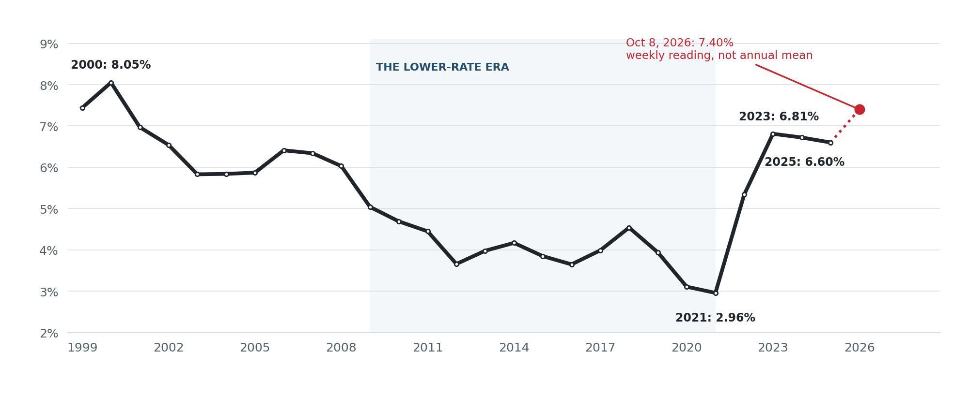
Source: Freddie Mac PMMS weekly observations, annual means as compiled from FRED [2]. The red 2026 point is the 8 October WEEKLY observation, not a 2026 annual average [1].
The 27 complete calendar years begin with 8.05% in 2000, fall into the 3–4% range during much of the 2010s, reach a 2.96% annual trough in 2021, then jump to 5.34% in 2022 and 6.81% in 2023. Although the 2025 annual average eased to 6.60%, the latest 7.40% reading has restored rates last experienced in late 2023. [1, 2]

Read the average carefully
Annual averages smooth over decisive changes within a year: 2022 began near 3.2% and touched 7.1% by October. Freddie Mac also changed its underlying data collection in November 2022. The 27-year chart is therefore a useful long-term compass, not a perfectly controlled experiment or a measure of what any individual borrower was quoted. [2, 11]
THE UNDERLYING ANNUAL SERIES
Year | Rate | Year | Rate | Year | Rate
1999 | 7.44% | 2008 | 6.03% | 2017 | 3.99%
2000 | 8.05% | 2009 | 5.04% | 2018 | 4.54%
2001 | 6.97% | 2010 | 4.69% | 2019 | 3.94%
2002 | 6.54% | 2011 | 4.45% | 2020 | 3.11%
2003 | 5.83% | 2012 | 3.66% | 2021 | 2.96%
2004 | 5.84% | 2013 | 3.98% | 2022 | 5.34%
2005 | 5.87% | 2014 | 4.17% | 2023 | 6.81%
2006 | 6.41% | 2015 | 3.85% | 2024 | 6.72%
2007 | 6.34% | 2016 | 3.65% | 2025 | 6.60%

DEAL FLOW / THE VOLUME CHANNEL

The market freezes before it falls
FIGURE 2 | Rates and US existing-home transactions, 2017–2025
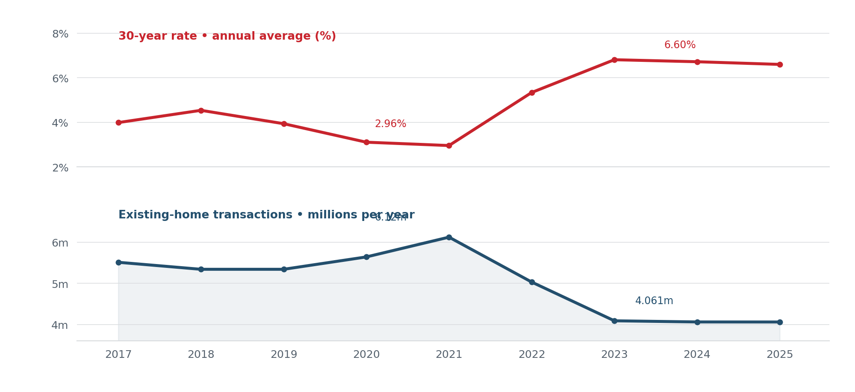
Rate: annual mean, Freddie Mac [2]. Transactions: annual counts, NAR historical figures [5, 6]. These are two parallel time series, not proof of an isolated causal effect.
The most persuasive comparison is 2021 against 2025. As the annual mortgage rate rose from 2.96% to 6.60%, existing-home sales fell from 6.12m to about 4.06m—a drop of 33.6%. The decline cannot all be credited to financing: pandemic distortions, employment, price gains, demographics and listings also matter. Yet the direction and scale illustrate why brokers experience a credit squeeze as fewer closings before it appears in assessed values. [2, 5, 6]
The latest national reading is consistent with that mechanism. August 2026 existing-home sales were running at a seasonally adjusted annual rate of 3.98m, down 2.0% month on month, while the median transaction price still rose 1.6% year on year to $429,100. Inventory was 1.62m units, or 4.9 months of supply. The annualized monthly pace is not the same measure as the full-year counts charted above. [4]

A traffic jam, not a crash
On the demand side, expensive monthly payments exclude marginal households. On the supply side, mortgage lock-in keeps owners in place. Freddie Mac’s benchmark captures owner-occupied conforming loans; investor property, non-owner-occupied fourplex and jumbo condominium financing may carry materially different quotes and underwriting conditions. [7, 11]

THE SOUTHWEST / SIX MARKETS

An uneven regional retreat
FIGURE 3 | Share of active home listings with price reductions, September 2026
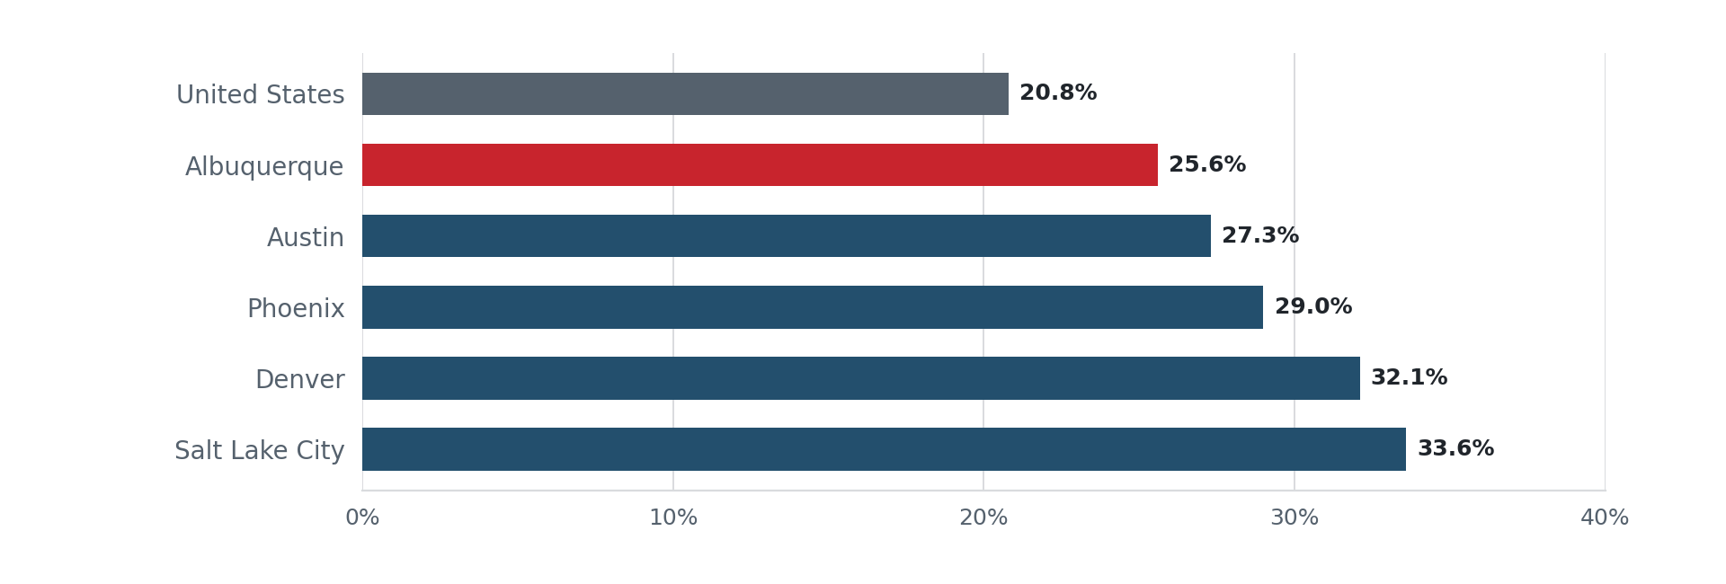
Source: Realtor.com September 2026 trends [8], with Albuquerque’s local September detail [9]. These are ASKING-PRICE cuts, not declines in closed-sale prices.
The Western region’s inventory rose 6.2% from a year earlier in September; the South’s rose 2.6%. Median asking prices fell 0.8% in the West and 2.4% in the South. Yet the southwest cities tell distinct stories, reflecting different construction booms, migration trends and local pricing. [8]
September 2026 market | Active listings YoY | Median list price YoY | With price cuts
Albuquerque, NM | +4.8% | +0.3% | 25.6%
Phoenix, AZ | +7.5% | −4.8% | 29.0%
Denver, CO | +6.7% | −4.9% | 32.1%
Salt Lake City, UT | +14.1% | −3.6% | 33.6%
Austin, TX | +1.4% | −9.8% | 27.3%
United States | +5.4% | −1.4% | 20.8%

Source: Realtor.com September 2026 published market statistics [8, 9]. Albuquerque values refer to the local September listing series; comparison is geographic, not an MLS-defined detached-home sample.

Why Albuquerque is different
The price cuts in Denver and Salt Lake City are larger and more numerous than in Albuquerque. Albuquerque’s listing prices have remained virtually unchanged even while about one in four sellers has marked down an asking price. A list-price reduction measures seller behaviour on active listings; median closing prices tell a different story, and can lag by the length of a contract and escrow. [8, 9]
In Phoenix, FHFA estimates that mortgage lock-in alone removed some 48,920 potential home sales from mid-2022 to mid-2024—among the largest impacts nationally. Hence additional listings in a region need not translate into plentiful transactions. [7]

GREATER ALBUQUERQUE / REAL ESTATE IN PRACTICE

Fewer closings, but little discount at the deed
Southwest MLS’s latest detailed monthly report available on 11 October covered August 2026. Its six-county detached-home sample is more precise about completed sales than the broader September online listing series; the two should not be conflated. [9, 10]
Detached houses | August 2025 | August 2026 | Change
Closed sales | 812 | 749 | −7.8%
Median sold price | $379,995 | $385,000 | +1.3%
Active listings | 2,215 | 2,285 | +3.2%
Months of supply | 2.7 | 3.1 | +11.8%
Median days on market | 18 | 18 | 0.0%
YTD closed sales | 6,258 | 6,235 | −0.4%
YTD median sold price | $370,000 | $379,700 | +2.6%

Source: Southwest MLS / Domus Analytics, August 2026 market summary, detached properties across Bernalillo, Sandoval, Santa Fe, Socorro, Torrance and Valencia counties [10].
Attached housing is softer still: August closings fell 25.3% (91 to 68) and median sold price dropped 10.6% (from $288,000 to $257,500). Because the attached segment is much smaller, its month-to-month medians can shift with the mix of homes sold. [10]

What the rate shock costs a buyer
FIGURE 4 | Principal and interest per month on an Albuquerque median-priced detached home
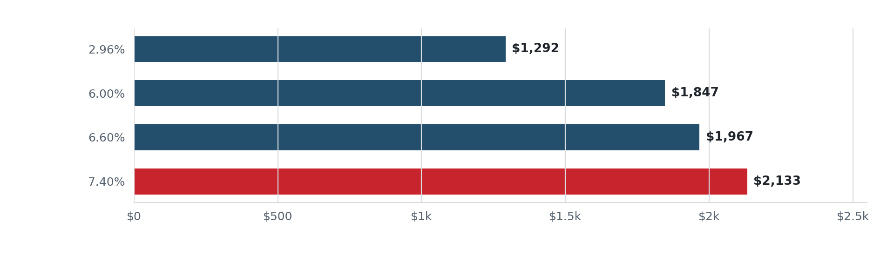
Illustration: $385,000 home, 20% down, $308,000 fixed principal, 30-year amortization. Excludes tax, insurance, HOA dues, PMI and closing costs. Rate scenarios are illustrative; 7.40% is Freddie Mac’s Oct 8 reading [1, 10].
Moving from 6.0% to 7.4% adds roughly $286 a month to this loan—about $3,430 a year—without changing the sale price. From the 2021 average of 2.96% to 7.4%, monthly principal and interest is roughly 65% higher. These calculations explain why a small reduction in list price may do little to restore affordability.
September’s broader online listing data add a later warning: 2,313 active listings (+4.8% year on year), a median listing age of 67 days and price cuts on 25.6% of advertisements. Those 67 days are the age of CURRENT listings, not the 18-day median for detached homes that closed in August. [9, 10]

OUTLOOK / NEXT 6–12 MONTHS

Three ways the stalemate could end
A forecast is a map of contingencies, not a promised mortgage quote or a prediction of the Fed’s next decision. The following scenarios consider the influence of sustained rate conditions into early or mid-2027, with employment, incomes and available supply held broadly stable.
Scenario / rate environment | Likely volume outcome | Likely price / negotiation outcome
High-for-longer • roughly 6.75–7.50% | Slow turnover persists; purchases sensitive to any new rate shock. | More price resets and seller concessions; uneven nominal prices.
Meaningful relief • about 6.0–6.5% | Qualification improves, pending sales and showings should rise before closings. | Better liquidity; popular submarkets may firm before regional medians respond.
Renewed squeeze • 7.75% or above | Financed activity weakens further; discretionary moves deferred. | Discount pressure concentrates in long-listed homes and high-supply subdivisions.

These thresholds are illustrative policy-neutral scenarios, not point forecasts. The watch-list is practical: weekly Freddie Mac rates; mortgage purchase applications; signed contracts and closed sales; months of inventory; share and depth of price cuts; and median time to contract. Compare like property types and consistent geographies. [1, 4, 8–10]

Implications for an Albuquerque real-estate strategy
For sellers: price against current competing inventory rather than peak-era closings, and examine a targeted temporary rate buydown against an equivalent price reduction. For buyers: negotiate both price and payment, and avoid treating a quoted rate as permanent until it is locked. For residential investors: stress-test rents, insurance, taxes, refinance proceeds and exit cap rates at borrowing costs above current owner-occupied benchmarks. A weaker owner-occupier purchase market can support rental demand even while higher debt costs make rental acquisitions harder.

Sources and method
Method: 27 full years (1999–2025) of simple calendar-year averages of Freddie Mac PMMS weekly national 30-year fixed rates, compiled from FRED. The 2026 7.40% figure is a single weekly point. National annual resale volumes are counts, whereas August 2026 national sales are quoted as a seasonally adjusted annualized pace. Metro list-price data, SWMLS closed-sales figures and active-listing days on market have distinct denominators and should not be equated. Source pages and links below were accessed 11 October 2026.
[1] Freddie Mac, Primary Mortgage Market Survey (2026 archive). https://www.freddiemac.com/pmms/archive?year=2026
[2] Freddie Mac PMMS / FRED annual series (CalculatorHub replication). https://calculatorhub.com/us/mortgage-rate-history/
[3] Reuters, US mortgage rates and weekly applications, 7 October 2026. https://www.reuters.com/world/us/us-30-year-mortgage-rate-hits-highest-nearly-three-years-2026-10-07/
[4] NAR, August 2026 existing-home sales, 10 September. https://www.nar.realtor/newsroom/nar-existing-home-sales-report-shows-2-0-decrease-in-august
[5] Realtor.com, 2025 annual existing-home sales, 14 January 2026. https://www.realtor.com/research/existing-home-sales-december-2025/
[6] NAR, historical housing sales figures, midyear outlook (2024). https://www.nar.realtor/sites/default/files/documents/real-estate-and-economic-outlook-midyear-nar-forecast-summit-lawrence-yun-presentation-slides-07-22-2024.pdf
[7] FHFA, geography and scale of mortgage lock-in, 30 August 2024. https://www.fhfa.gov/blog/statistics/the-geography-of-the-lock-in-effect-which-msas-are-most-locked-in
[8] Realtor.com, September 2026 housing trends. https://www.realtor.com/research/september-2026-data
[9] Realtor.com, Albuquerque September 2026 local market. https://www.realtor.com/news/local/albuquerque-nm/real-estate-market-albuquerque-nm-september-2026/
[10] GAAR / Southwest MLS, August 2026 detailed market report. https://www.gaar.com/images/uploads/statistics/Full_Market_Report_2026_08.pdf
[11] Freddie Mac, mortgage survey methodology changes (2022). https://www.freddiemac.com/research/insight/20221103-freddie-macs-newly-enhanced-mortgage-rate-survey

